**Plugging Into The Future: An Exploration Of Electricity Consumption Patterns**

## Project Description:

India is the world's third-largest producer and third-largest consumer of electricity. The national electric grid in India has an installed capacity of 370.106 GW as of 31 March 2020. Renewable power plants, which also include large hydroelectric plants, constitute 35.86% of India's total installed capacity. During the fiscal year (FY) 2019–20, the total electricity generation in the country was 1,598 TWh, of which 1,383.5 TWh generated by utilities. The gross electricity consumption per capita in FY2019 was 1,208 kWh.In 2015-16, electric energy consumption in agriculture was recorded as being the highest (17.89%) worldwide. The per capita electricity consumption is low compared to most other countries despite India having alow electricity tariff. In light of the recent COVID-19 situation, when everyone has been under lockdown for the months of March to June the impacts of the lockdown on economic activities have been faced by every sector in a positive or a negative waThe dataset is exhaustive in its demonstration ofenergy consumption state wise.Analysing Electricity Consumption in India from Jan 2019 till 5th December 2020. This dataset contains a record of Electricity consumption in each states of India, here we are going to analyse State wise , Region wise and Overall Electricity consumption in india

PROBLEM DEFINITION AND DESIGN THINKING:

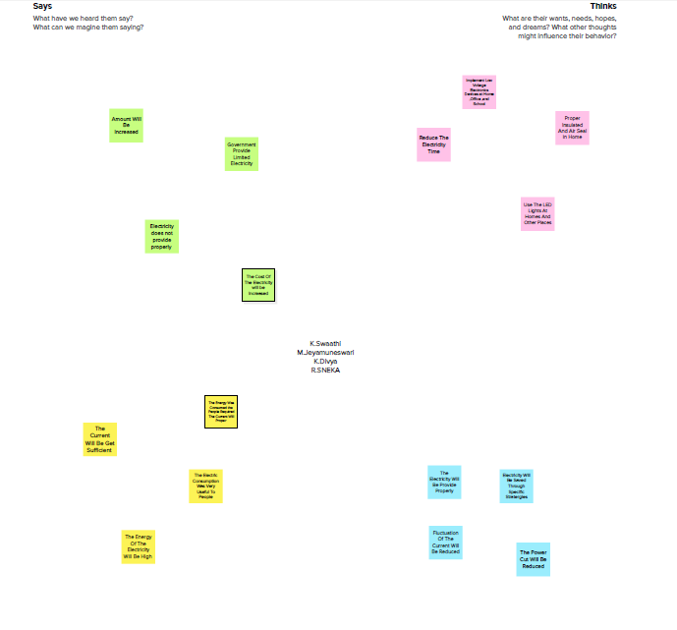

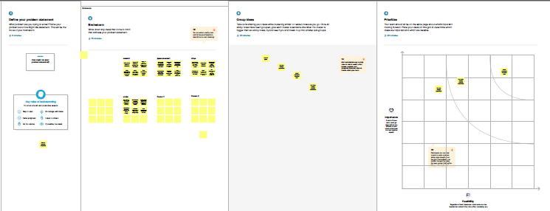

RESULT:

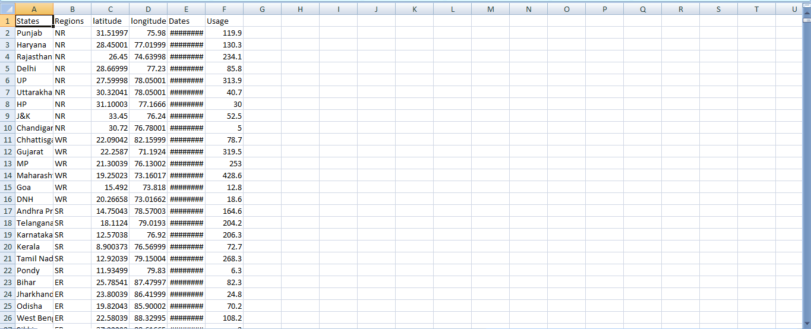

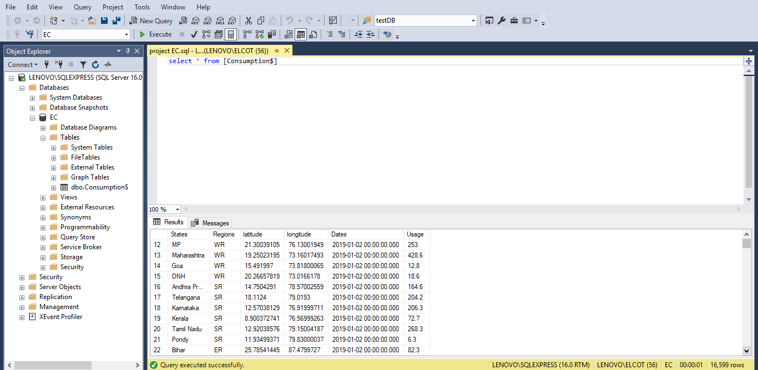

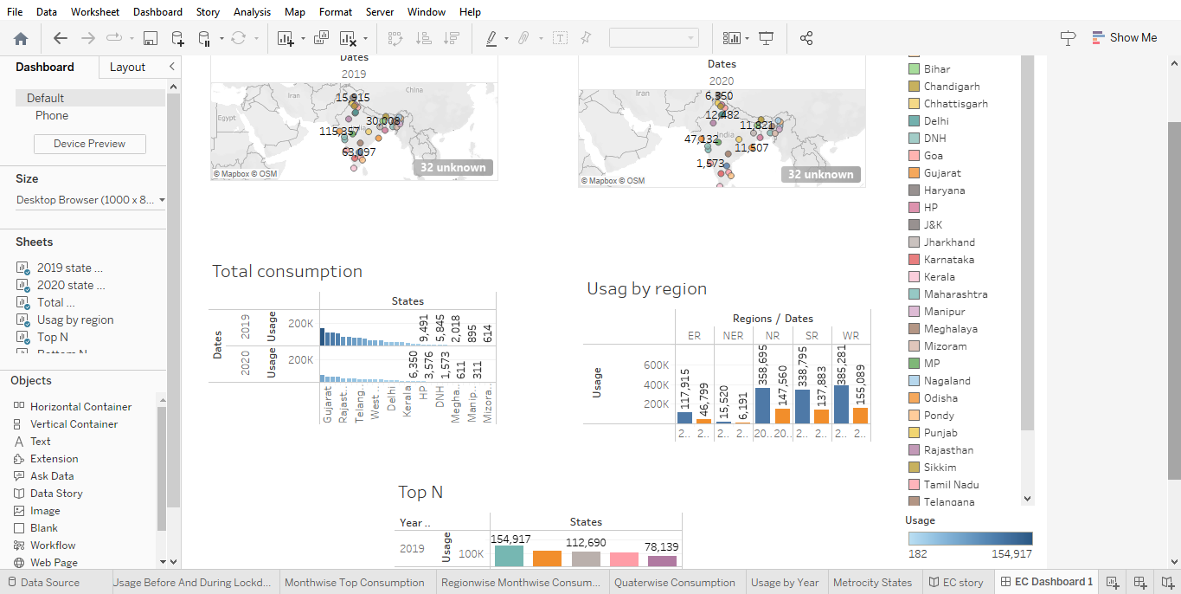

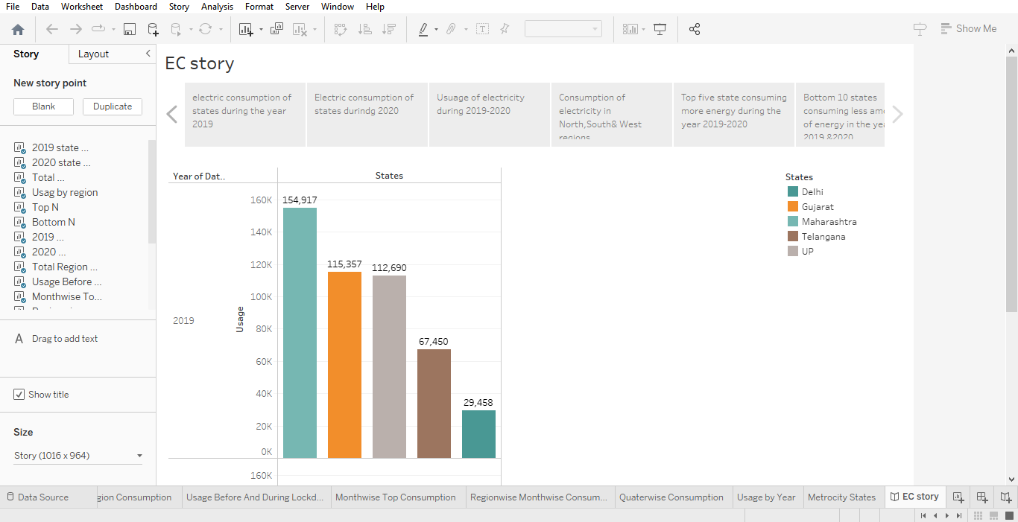

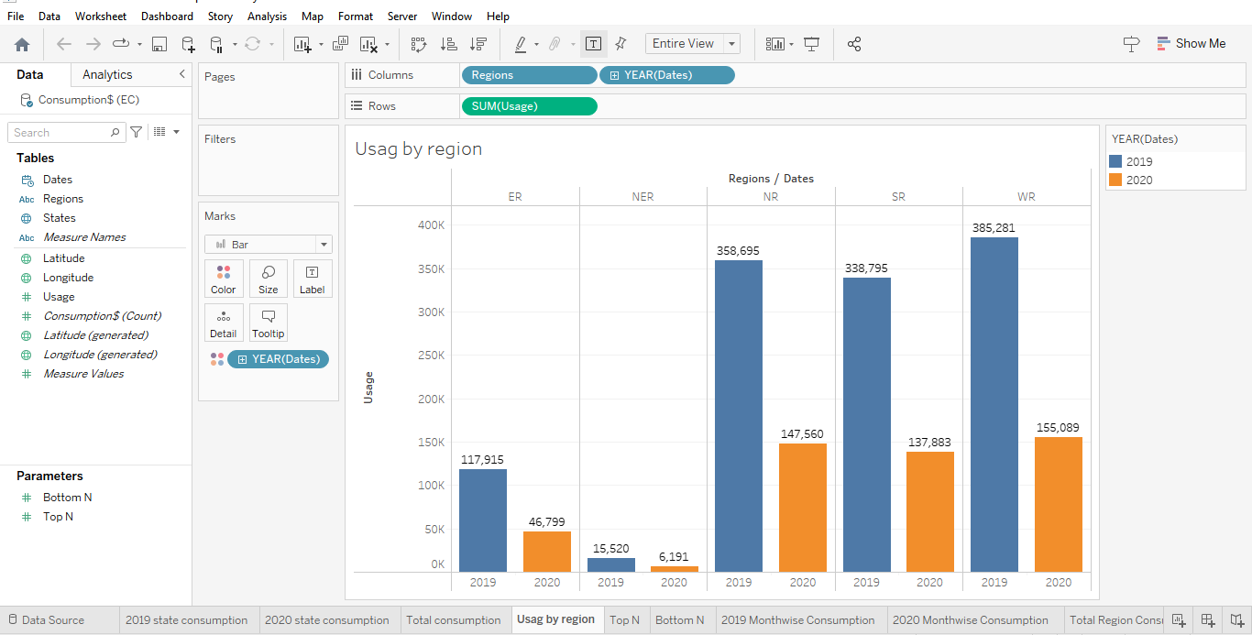

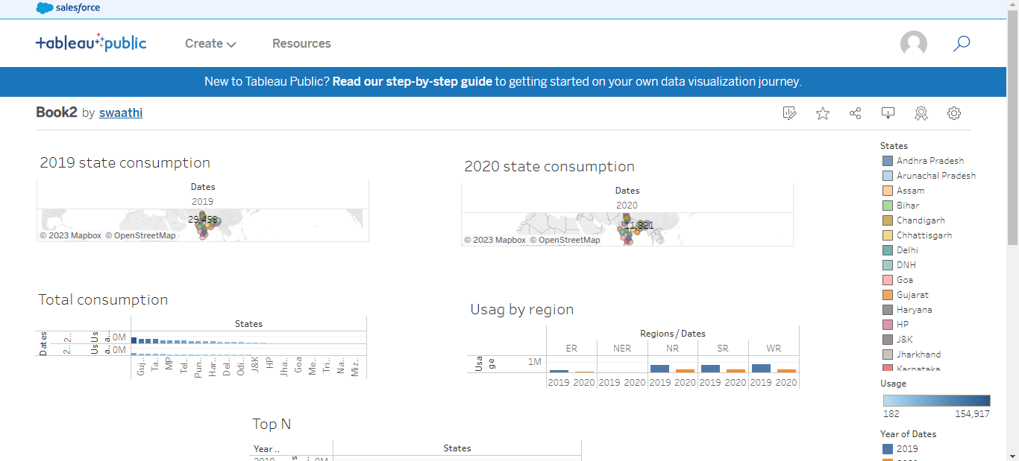

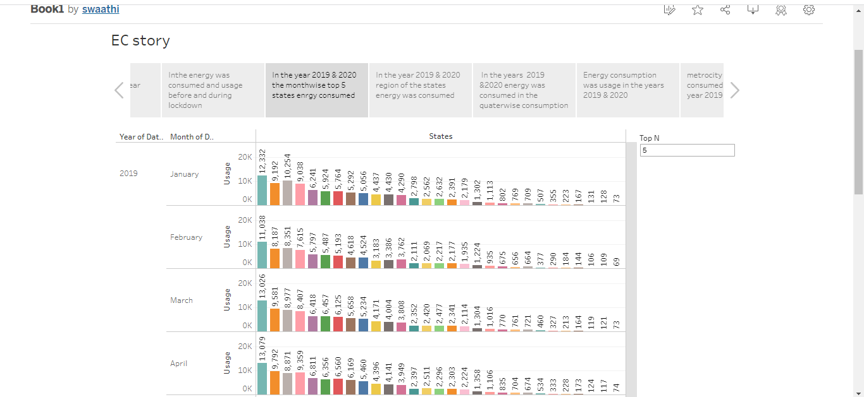

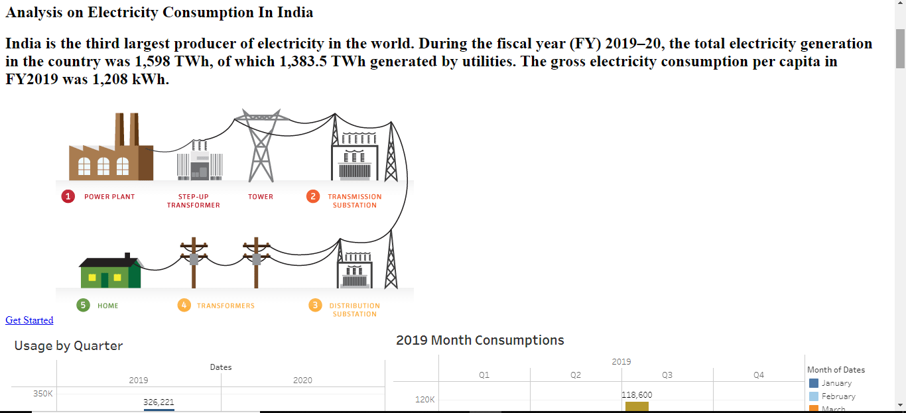

ADVANTAGES:

* a clean, safe, cheap and convenient source of energy.
* Lower maintenance cost.
* More efficient.
* No tailpipe emission.
* We all know that it can be set up in many sizes.
* It doesn't require as many employees.
* Reduces greenhouse emission.

DISADVANTAGES:

The environmental problems directly related to energy production and consumption include air pollution, climate change, water pollution, thermal pollution, and solid waste disposal

APPLICATION:

* Cooling and heating: 47% of energy use.
* Water heater: 14% of energy use.
* Washer and dryer: 13% of energy use.
* Lighting: 12% of energy use.
* Refrigerator: 4% of energy use.
* Electric oven: 3-4% of energy use.
* TV, DVD, cable box: 3% of energy use.
* Dishwasher: 2% of energy use

CONCULSION:

Conclusion. Current through a given area of a conductor is the net charge that passes per unit time through the conductor. To keep up a gradual current, we must have a circuit within which an electrical phenomenon occurs from lower to higher mechanical energy.

FUTURE SCOPE:

In the Stated Policies Scenario, global electricity demand grows at 2.1% per year to 2040, twice the rate of primary energy demand. This raises electricity's share in total final energy consumption from 19% in 2018 to 24% in 2040.

APPENDIX:

VIDEO DEMONSTRACTION:

<https://drive.google.com/file/d/1VXHuwNcSyjoifw7zEyUkqK2Uo3-XYT6z/view?usp=drivesdk>

TABLEAU PUBLUC DASHBOARD :

<https://public.tableau.com/app/profile/swaathi4221/viz/Book2_16821710015590/ECDashboard1?publish=yes>

TABLEAU PUBLISH STORY: <https://public.tableau.com/app/profile/swaathi4221/viz/Book1_16821708592630/ECstory?publish=yes>